The guidance below is always subject to the River Level. The maximum recommended wading depth is when the River Level is no greater than 0.4. Anglers must use their own judgement as to when it is safe to wade. At lower river levels more points of access and crossings will be available. Need also to be aware that the river bottom can change significantly from one season to the next – for good and bad.

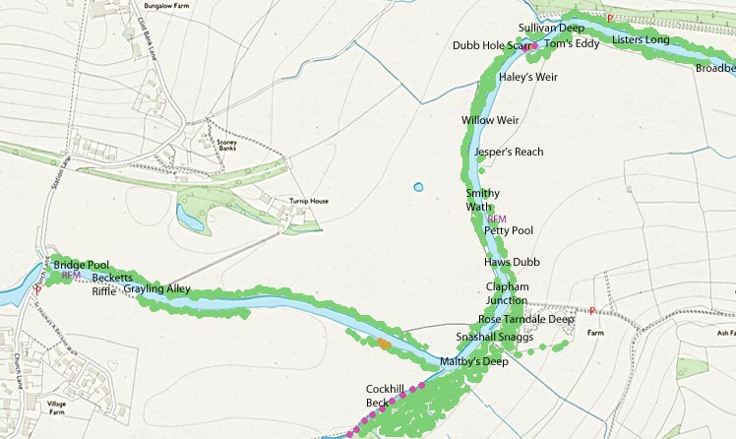
Access to the River
Easy
Moderate
With Care
River Crossing Point
Swim
P Parking
RFM River Fly Monitoring Site
The bank here is steep but the river is accessible with care
There are steps here into the river but they can be covered in high water
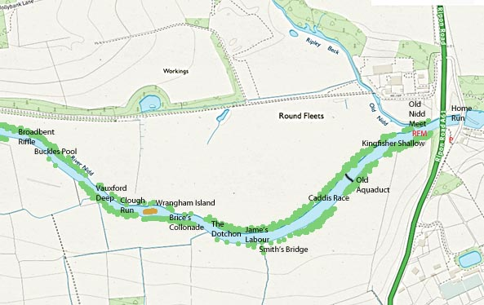
Drop down the bank to some steps that lead to a gap to the river. The route to the steps are marked by a vertical post
Slip through the barbed wire fence where the black plastic protective sleeves are. There are some steps to the river
Drop down the bank to the river
Drop down the bank between the two drainage ditches to the river

